**Eagles Crossing Golf Club, “Big Spring Men’s League”**

**Section 1.** **NAME**: This league shall be known as the **“Big Spring Men’s League”.**

**Section 2**. **DAY and TIME**: The league will play Tuesday evenings with a shotgun start promptly at 5:30pm.

Start time 5:00 pm starting the first week of September.

**Everyone should leave the club house by 5**:**25 to their starting hole.**

**Section 3**. **OBJECTIVE**: The purpose of this league is to conduct golf activities to foster and maintain the spirit of good fellowship and true sportsmanship.

**Section 4**. **MEMBERSHIP AND ELGIBILITY**: Individual eligibility for league play must be 18 years of age prior to the start of league play. Each team **MUST** consist of a 2-man team. At least one of the two must be on the team roster. **(Your team cannot consist of two subs)**

**Section 5**. **Cost:** **The cost per week will be: $21.00 per week for the golf.**

Prize money must be paid before the start of the second round.

**The total for the year will be $80 per player or $160 per Team (20 weeks @ $4.00 per week)**

This is non-refundable.

**Please give Prize Money to Doug Lautsbaugh. No Cards will be excepted / Cash or Checks ONLY made payable to: Eagles Crossing Golf Club**

Prize money will be 100% pay-out. Pay-out of the prize money will be determined after we know how many teams are in the league.

There will be an optional skins game each week. That will be a $3.00 pay in and 100% pay out. Skins will be **CASH ONLY** with a sign in on the counter. (**MAKE SURE YOU SIGN THE SHEET**) If there would be a complete carry-over from one week to the next and you did not play the week of a carry over, you can pay double and enter.

There will also be a **Closest to The Pin** (**must be on the green**) contest each week on one of the par three’s. This will cost $1.00 per week if you choose to enter. 100% pay out.

**End of year payout**: 100% TBD

**Section 6**. **CAPTAINS**: Each team must select one of the regular players as the team captain. This person is responsible for:

1. Making sure both of you check in and pay before 5:15pm.
2. Making sure the score cards are filled out correctly and turned into the club house at the end of the round. **Home team keeps the score for both groups.**
3. Reporting any problems that could come up or suggestions. Team captains will then get together vote on a solution to the problem.
4. **HOME TEAM HAS THE OFFICIAL SCORE CARD. ONCE IT IS TURNED IN THERE WILL BE NO CHANGES!!**

**Section 7**. **SCHEDULE**: The league shall start the season in April and end on approximately 20 weeks later. There will be two weeks of the play-offs that every team will be part of. Rain dates and Holidays will be added as needed, therefor extending the season.

**(schedule will be posted after we know the number of teams)**

**Section 8**. **HANDICAP**: The handicap allowance shall be 80% and will be figured on a par 36. Individual handicaps will be computed after the completion of the first round. There will be a maximum handicap of eighteen (18) strokes per person. The difference between handicaps shall be applied to holes being played from the hardest to the easiest using the men’s handicap on the scorecard for the nine holes being played.

**HANDICAP SCALE**

|  |  |  |
| --- | --- | --- |
| **STROKES OVER PAR** |  | **HANDICAP** |
| **1** | = | **1** |
| **2** | = | **2** |
| **3** | = | **2** |
| **4** | = | **3** |
| **5** | = | **4** |
| **6** | = | **5** |
| **7** | = | **6** |
| **8** | = | **6** |
| **9** | = | **7** |
| **10** | = | **8** |
| **11** | = | **9** |
| **12** | = | **10** |
| **13** | = | **10** |
| **14** | = | **11** |
| **15** | = | **12** |
| **16** | = | **13** |
| **17** | = | **14** |
| **18** | = | **14** |
| **19** | = | **15** |
| **20** | = | **16** |
| **21** | = | **17** |
| **22 and Over** | = | **18** |

**Section 9. PLAY**: Play will be from the White Tees for players age 55 and under. Players 55 and older may play from the Gold Tees. You must turn 55 the year of the league. 70 and older may play from the Red Tees.

**This decision must be made the first night of the league and you must play those tees every hole every week.**

Each week individuals will be paired together with two team members from another team. This will be done by the **TEAM CAPTAIN**. There will be NO changes on the order of players once the Home TEAM CAPTAIN has entered the lineup. The team that is listed first on the schedule will be the **Home Team.**

**(PLEASE ENTER LAST NAME AND INITIAL ON SCORECARD AND SCORE SHEETS CLEARLY)**

**Section 10**. **SCORING**: Scoring will be based on holes played using handicap to determine the winner of each hole. If a hole isn’t played or finished by both players**, (for any reason)** your score for that hole will be par plus any handicap strokes to which you’re entitled based on your League Handicap. An “X” should go in front of your score for that hole on the score card. If you forfeit a hole, you also forfeit the total point for your match.

There shall be a total of 10 points awarded during each individual match. One point for each hole and one point for total net using the person’s handicap. If there is a tie on a hole each player would receive a ½ point for that hole. There are 20 points possible per 2-man team, per match. **Max score on any hole will be double par. Please announce to the home team your score after each hole, so there are NO questions. NO SCORES WILL BE CHANGED ONCE THE CARD IS TURNED IN TO THE CLUBHOUSE. HOME TEAM HAS THE OFFICIAL SCORE CARD. DOUBLE CHECK BEFORE THEY ARE TURNED IN. HAVE THE CAPTAIN FROM THE VISITING TEAM SIGN THE CARD.**

**Section 11**. **WINTER RULES/LIES**: Winter are defined as Lift, Clean, and Place, without penalty, within one **CLUB HEAD** length of the original lie, no closer to the hole. (**SAME CUT**) This rule **cannot** be used to bring a ball back in from Out-of-Bounds, from behind a tree, or out of a hazard. (marked with white, red, and yellow stakes) If a ball is hit **OB** or have a **LOST BALL** take distance and a **ONE STROKE** penalty stroke. Take two club lengths and play the ball from where it went out of bounds or last crossed the hazard, not where you find the ball. **(Hole 14, if you attempt to go over the trees and do not make it. You must drop where it crossed over the trees. Do not drop on the green side of the tree’s)** **Do not play a second ball from the tee box**. Make sure you concur with the person you are playing against. This will help with the pace of play. **Lateral Hazard** is a **ONE STROKE** penalty. Take two club lengths and play the ball from where it went in.

**GIVE-ME-PUTTS**: Even if you are given a putt, **it still counts as a STROKE**.

**Section 12. TEAM ROSTERS:** Teamrosters will be limited to 5 players, with 2 men playing each week. If a team has a player that cannot finish the season after the halfway point,we will make a decision at that time**.**  Teams are required to have at least 1 regular player from their roster to have a legal lineup for that match.

**Section 13**. **ABSENTEE**: When there is an absentee, match points shall be awarded accordingly.

When your opponent is absent, you will play against **PAR** for the evening, while receiving your entire handicap allotment. If your net score (after handicap allotment) is par, you ½ the hole and receive ½ a point. If your net score is birdie (after handicap allotment) you win the hole and get 1 point. If your net score is bogey or worse,

(after handicap allotment) you lose the hole, as well as the point. You will receive 1 point for low net for the evening, regardless of your score.

**Section 14. Subs:** There will be a list of men that are willing to sub for any team if you need someone. That list will be on the schedule. **It is the players responsibility to get a sub**. “**Do Not”** call the course the day of the league and expect them to find you a sub. A sub **cannot** be a player from another team’s roster. If you have someone that would like to be on the sub list, please let us know so we can add their name to the list.

**The sub is responsible for paying $21.00 that night (Golf Fee) If you choose to pre-pay for your sub that’s fine too.**

**Either way the Golf Fee must be paid in full that night.**

**Section 15**. **POSTPONEMENTS**: All postponements will be made by the Management at Eagles Crossing. For any reason they feel the course is unplayable, the Team Captains will be notified by 4:00PM. If bad weather happens during a match: After 5 holes are completed it is considered a match.

**Section 16**. **Play-Offs**: Every team will be involved in the play-offs. Players must have at least 10 rounds played to be qualified for play-offs. **If there is a tie getting into the top four places, we will revert back to the winner of the match between the two teams during the regular season. Subs cannot be used during play-offs unless they have played 10 rounds in the league**.

**Playoffs**: Last Two Weeks for everyone, Three Weeks for the Top 8 Teams

**(First Round) SEE BRACKETS**

Top 4 from each Division advance / 8 Teams

Teams that do not make the top 4 you will either play the same place cross over or the next team in the standings for ending position.

**(Second Round) SEE BRACKETS**

Teams that do not make the top 4 you will play a Scramble. Prize Money will be Paid out for teams not in the final 8.

**(Final Round) 5:00 PM Start**

Top 8 Teams Only – Pay out following the round

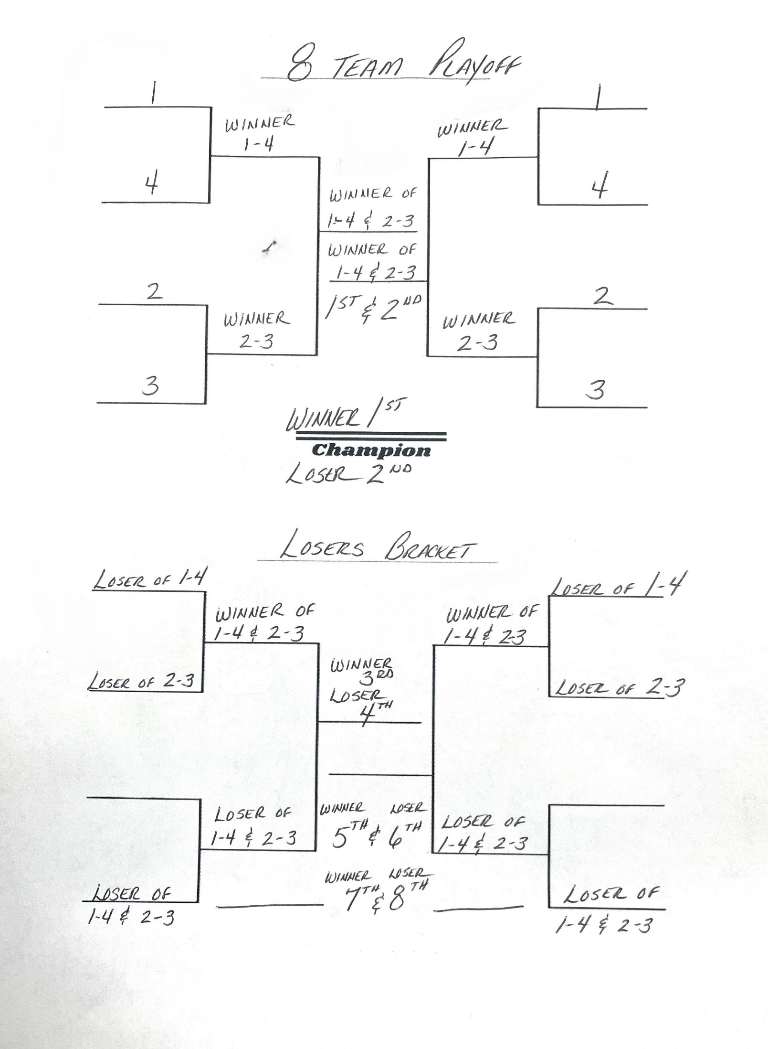

**TIES**: Ties during play-offs will be decided by the team’s net score that night.

**Big Spring Golf League Tie Breaker Criteria:** Any ties for the first four places after the last week of the regular season will be broken as follows:

1. Winner of Head to Head matchup between the two teams tied will be considered the higher team.
2. If there is no Head to Head match-up, the total rank of all opponents played thru the entire season will be added up for the tied teams, and the team with the lowest total number will be the winner.

**(See Shawn Snyder with any questions)**

1. Tied matches during the playoffs will be determined by the team with the lowest total net score for that evening.